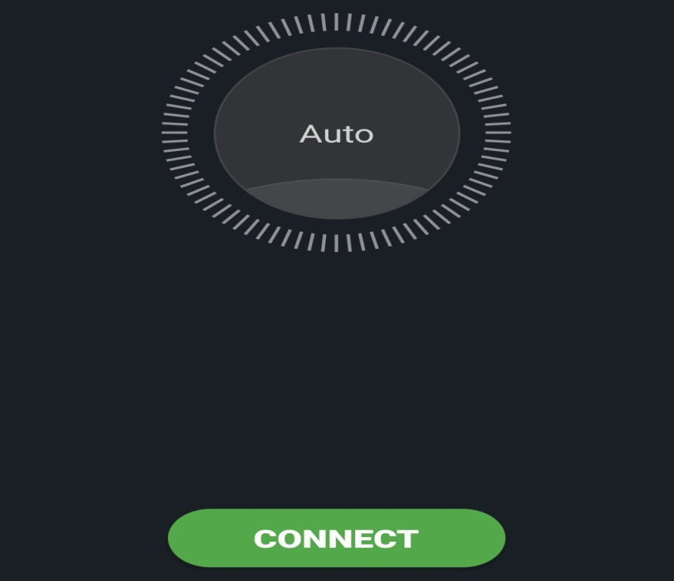WHEN NOT CONNECTED TO VPN(inside india)

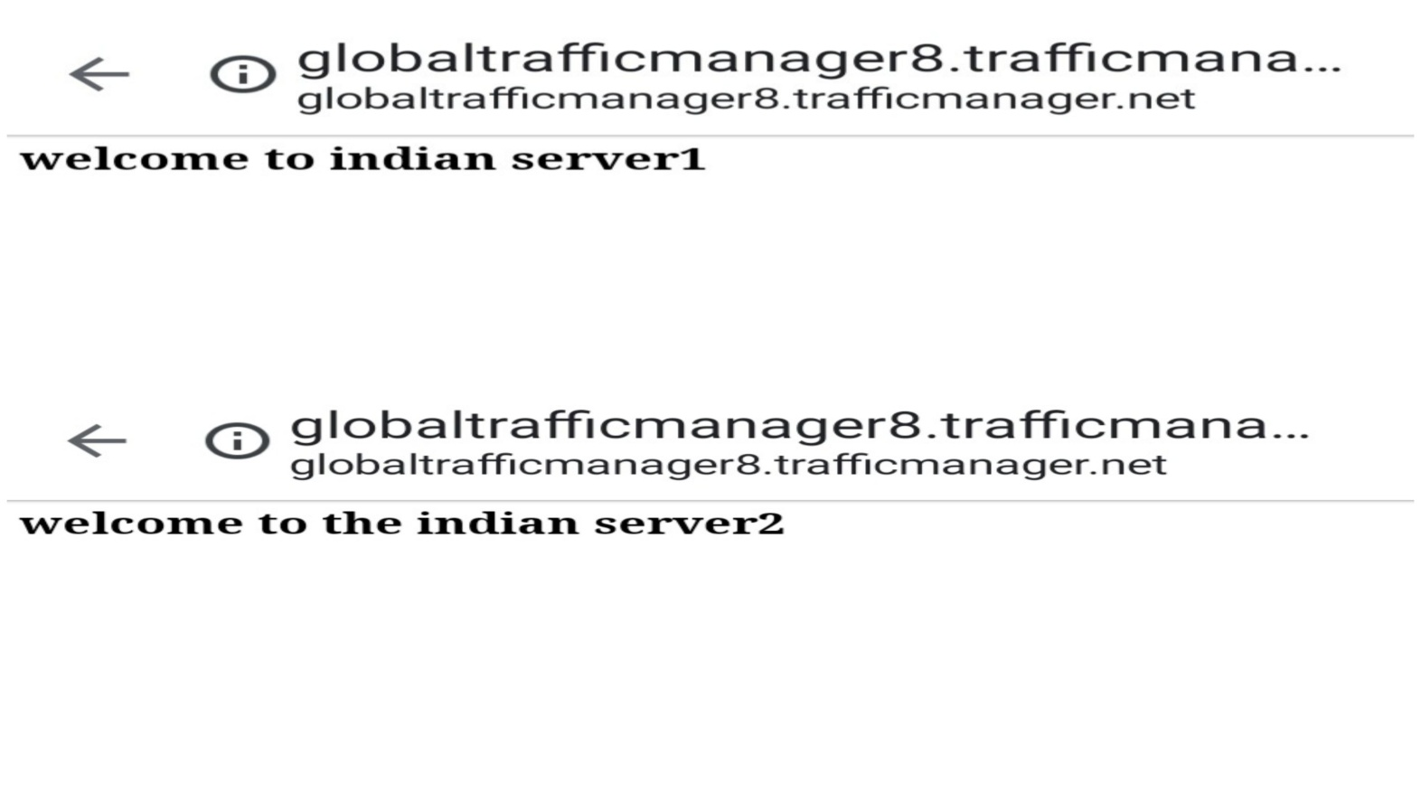CONNECTS TO INDIAN SERVERS

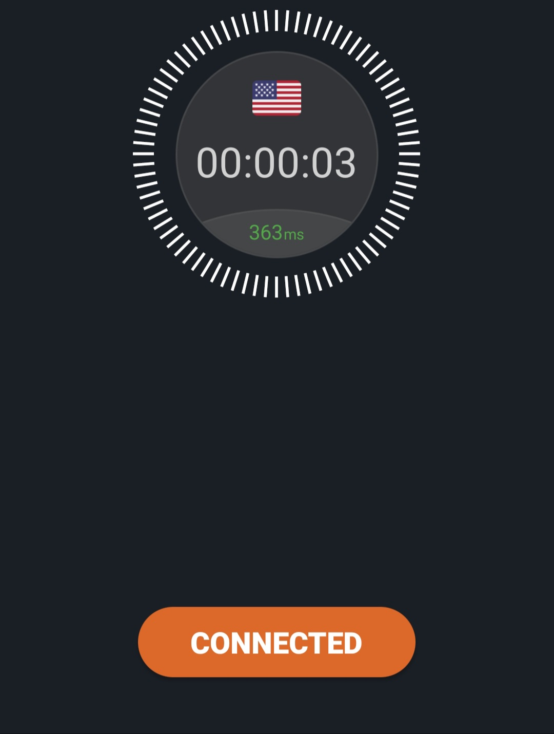WHEN CONNECTED TO VPN(other countries)

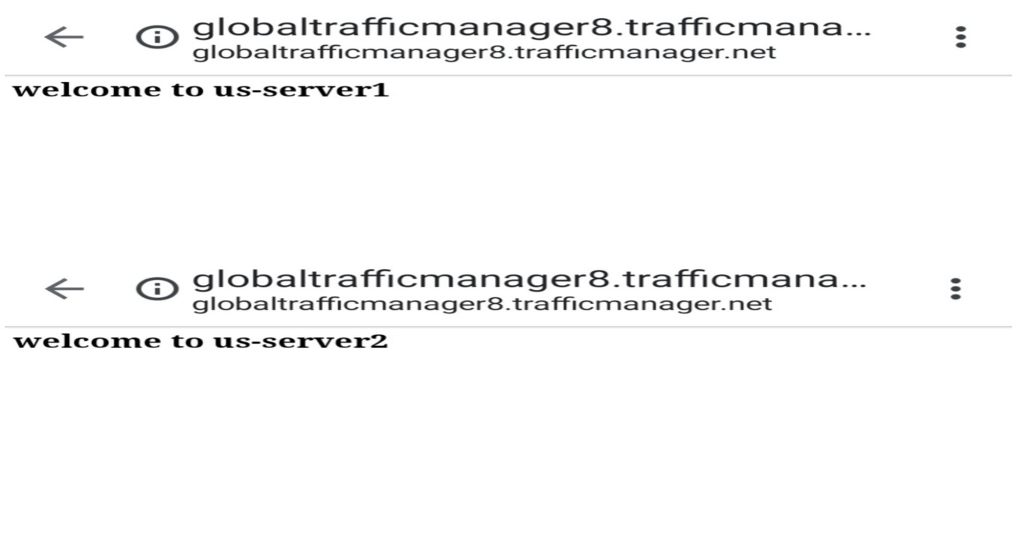CONNECTS TO US-SERVERS

LINK----------------------------------------------------------------------------🡪>>>>>>>>>>>>>>>>>>>>>>>> http://globaltrafficmanager8.trafficmanager.net